Cascaded Style Sheet

Ex1:-

<!DOCTYPE html>

<html lang="en">

<head>

    <style>

        h1{

            background-color:red;

            color:white;

            padding:5px;

        }

        p{

            color:blue;

        }

    </style>

</head>

<body>

    <h1>Write your First Css Example</h1>

    <p>This is paragraph</p>

</body>

</html>

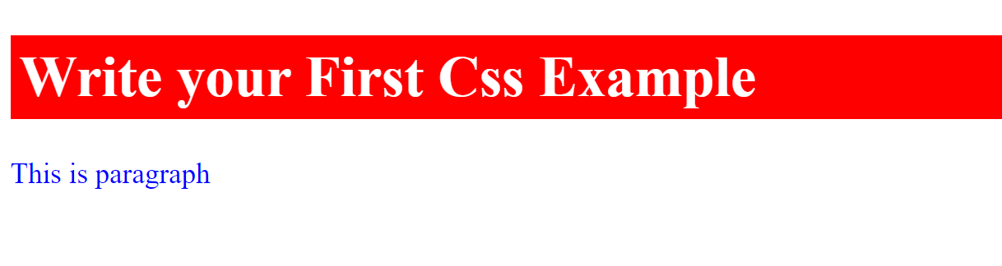

Syntax:-

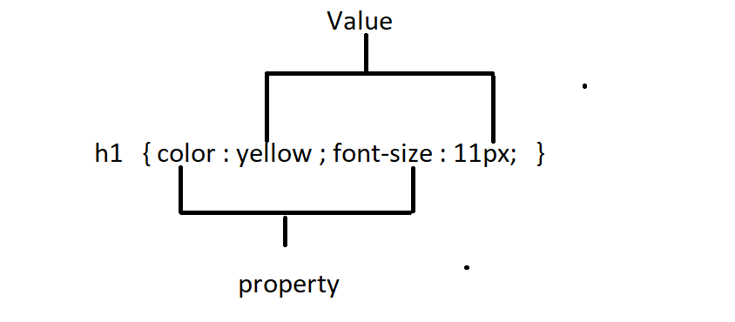

Selectors In Css

1)Html Selector

2)Id Selector

3)Class Selector

4)Universal Selector

5)Group Selector

1)Html Selector:-

<!DOCTYPE html>

<html lang="en">

<head>

    <style>

        p{

            text-align: center;

            color: #ff0000;

        }

    </style>

</head>

<body>

    <p>Hello Css!</p>

</body>

</html>



2)Id Selector:-

\*its unique

\*its always start with hash symbole(#)

<!DOCTYPE html>

<html lang="en">

<head>

    <style>

        #p1{

            text-align: center;

            color:red;

        }

    </style>

</head>

<body>

    <p id="p1">Hello VF pages</p>

    <p>Hello LWC Components</p>

    <p></p>

</body>

</html>



3)Class Selector:-

\*its create with period symbol(.)

\*its not be unique

<!DOCTYPE html>

<html lang="en">

<head>

   <style>

       .c1{

           text-align: center;

           color:blue;

           font-size: 10px;

       }

   </style>

</head>

<body>

    <h1 class="c1">This is heading with blue color text and align is center</h1>

    <p class="c1">This is paragraph with blue color text and align is center</p>

    <div class="c1">This is div with blue color text and align is center</div>

</body>

</html>

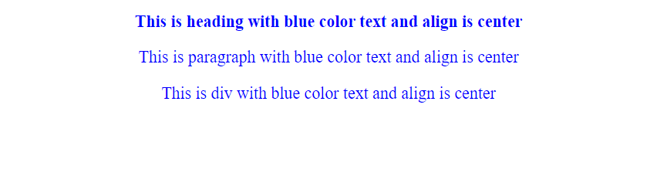

Ex2:-class also allows multiple classes in single class attribute

<!DOCTYPE html>

<html lang="en">

<head>

   <style>

       .c1{

           text-align: center;

           color:blue;

           font-size: 10px;

       }

       .c2{

           background-color:aqua;

       }

   </style>

</head>

<body>

    <h1 class="c1">This is heading with blue color text and align is center</h1>

    <p class="c1 c2">This is heading with blue color text and align is centerparagraph with blue color text and align is center</p>

    <div class="c1">This is div with blue color text and align is center</div>

</body>

</html>



4)Universal Selector:-

\*it defines with an asterisk symbole(\*)

<!DOCTYPE html>

<html lang="en">

<head>

    <style>

        \*{

            font-family:Arial,Verdana, Geneva, Tahoma, sans-serif;

            color:cyan;

            font-style: italic;

            font-weight: bold;

        }

    </style>

</head>

<body>

    <h1>This is heading</h1>

    <p>This is p tag</p>

    <div>this is div tag</div>

</body>

</html>

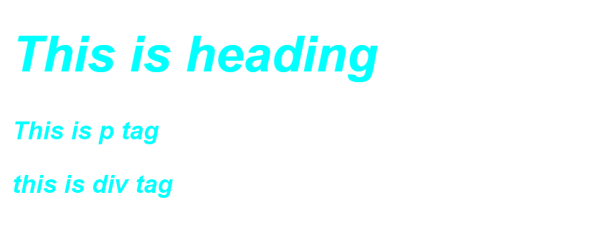

5)Group Selector:-